**BRIEF REPORT**

**ICI**(OLM 11754),**ACCE(I)**(OLM-4319) & IGBC Student Chapters of AMC ENGINEERING COLLEGE,Bengaluru-560083 jointly organized the **NATIONAL SEMINAR FOR RESEARCH SCHOLARS** (NSRS 2017) during **16-17, March 2017**.

Dr.SHASHISHANKAR A, the Convener & Professor/Head Civil Engineering AMCEC, welcomed the gathering & explained the significance of NSRS 2017.

Coordinators were Prof.MOHIYUDDIN C S (ACCE-I), Prof.ANAND (IGBC), Prof.RAVITHEJ (ICI).

The objective was achieved through four levels of paper presentation

1. Ph.D. scholars & Academia
2. M.Tech Students.
3. BE/ B.Tech mock presentation.
4. Industrial Research.

100 participants from across the country included renowned Institutes such as IISc Bengaluru,IIT-Kharagpur, SRM University Chennai, Thapar University, Osmania University, JNTU-A , SRIT , BU, VTU & Jain University etc, who actively participated by presenting research papers in the field of Civil Engineering & interdisciplinary Research in Built Environment.

Day 1, Parallel Technical sessions were inaugurated by Dr.N.P.Rajamane, Head, Centre For Advanced Concrete Research (CACR), SRM University who stressed the need for mitigating climate change through technologies with low carbon footprint such as Geopolymer Concrete.

Plenary Session was addressed by Dr.T.V.Ramachandra, Head, Centre for Environment & Sustainability, IISc, Bengaluru who gave a detailed technical presentation on the growth of Bengaluru City in a manner jeopardizing the Ecological system.

Day 2 , Parallel Technical sessions were inaugurated by Dr.R.GANESH RAJ, Director-RESPOND, ISRO HQ, who imparted the awareness about Extra mural Research funding & other grants available from ISRO for the benefit of research scholars & institutes.

Dr. R. Jeyalakshmi, Professor & Head, Dept. of Chemistry, SRM University, Chennai & Prof. BOPALAN of SRM University gave presentation on GEOPOLYMER CONCRETE RESEARCH at CACR.

The following awards were instituted & presented

1.Dr.N.P.Rajamane - Dr.VIJAYARANGAN AWARD for Excellence in Geopolymer Research.

2. Dr.R.Jeyalakshmi –Dr.JOSEPH DAVIDOVITS AWARD for Excellence in Geopolymer Chemistry Research.

3. Dr.T.V.Ramachandra- Dr.MADHAV GADGIL AWARD for Excellence in RESEARCH ON WESTERN GHATS.

4. Er.Ajit Sabnis- Dr.AMULYA K N REDDY AWARD for Excellence in Carbon Neutrality & Built Environment Research.

5. Dr M.N.HEGDE- Dr. KTS IYENGAR AWARD for Excellence in Structural Dynamics Research.

6. Dr.R.Ravindra – Sir.M.V AWARD for Excellence in Structural Reliability Research.

The Following prizes were bagged by

1. The All India Best University Award for research in Concrete & Composites – SRM University CHENNAI.
2. The All India Best Institute – Srinivasa Ramanujan Institute of Technology, under JNTU-A.
3. The Best Paper Award – Vinay S, Research Scholar, IISc Bengaluru

PHOTO GALLERY NSRS 2017

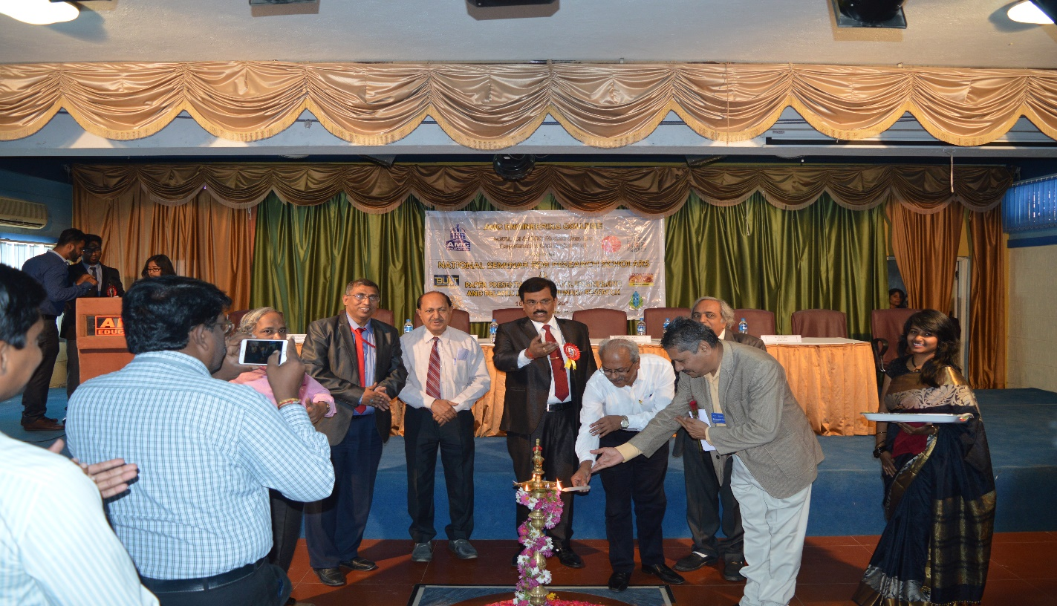

INAUGURATION OF NSRS 2017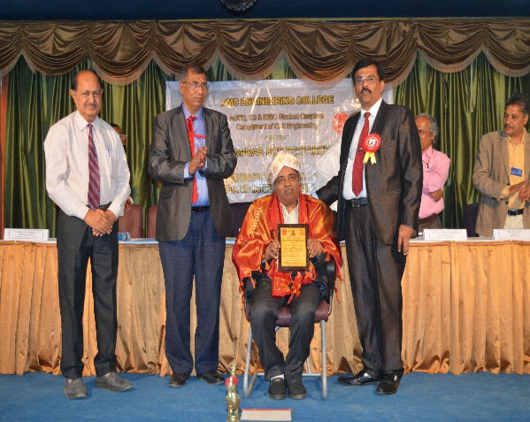

HONOURING THE WIZARD Dr.N.P.RAJAMANE, HEAD CACR, SRM-U, CHENNAI.

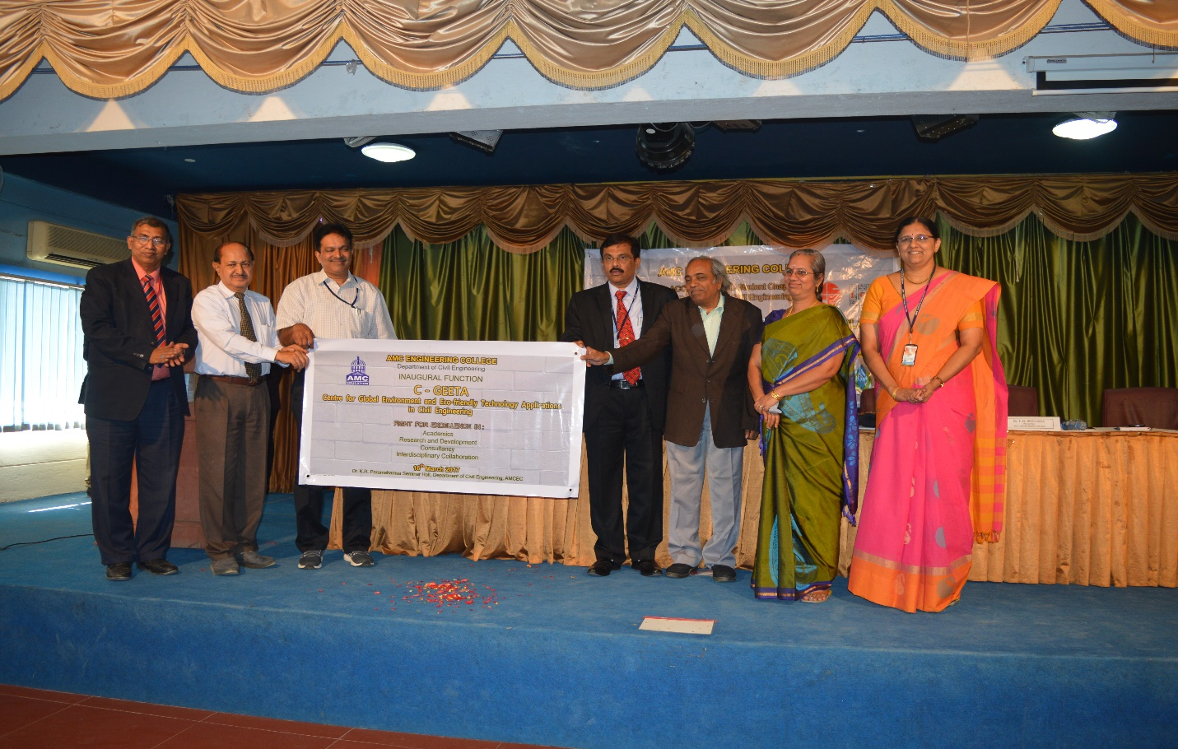LAUNCHING OF CENTRE FOR GLOBAL ENVIRONMENT & ECO FRIENDLY TECHNOLOGYAPPLICATIONS IN CIVIL ENGINEERING. (C-GEETA)  
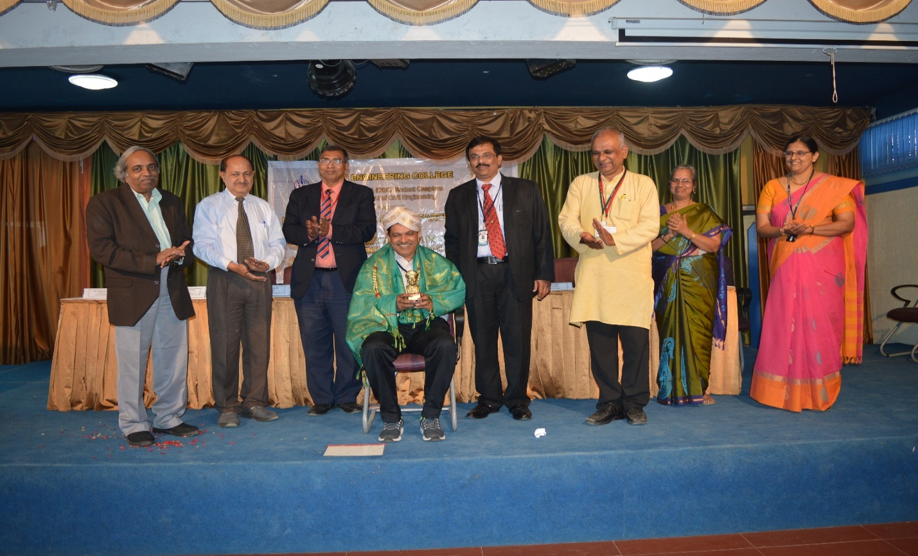

Felicitation to Dr. R. GANESH RAJ, Director-RESPOND, ISRO HQ

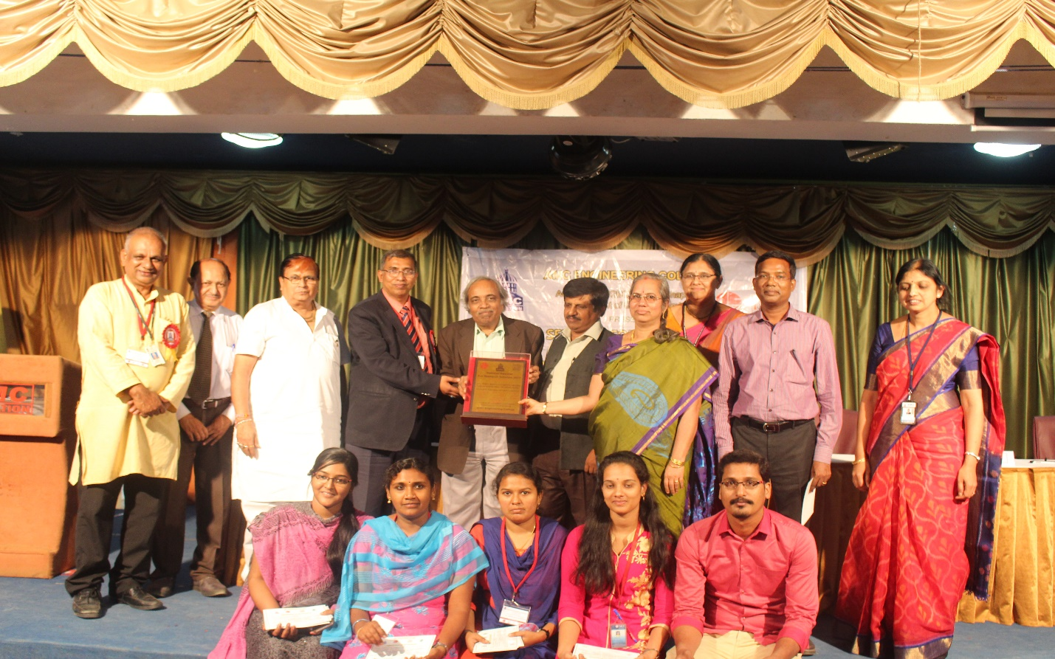

SRM-University Research Team receiving the BEST UNIVERSITY AWARD.

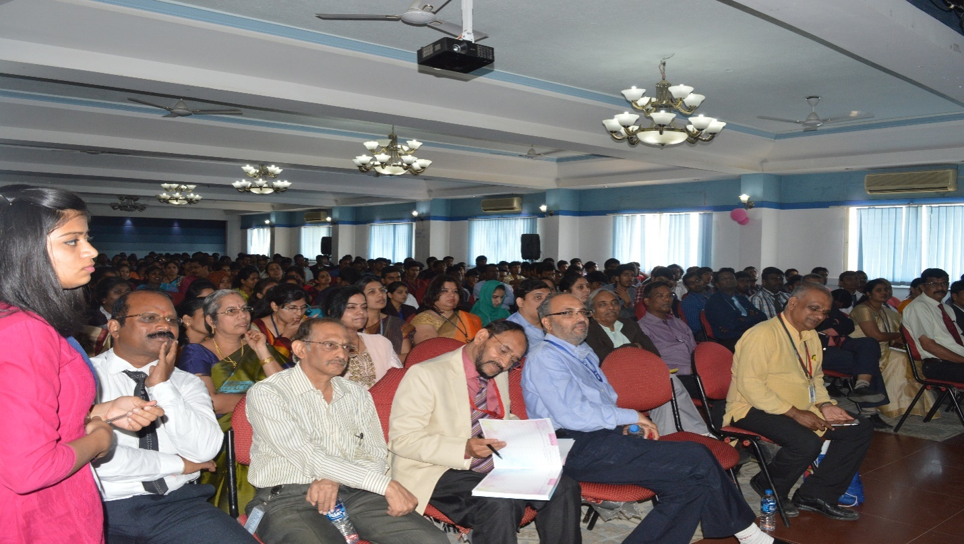

CONFLUENCE OF RESEARCH SCHOLARS-NSRS 2017