Report on National Workshop

**On**

*“***Advances in precast**

**construction TECHNOLOGY:**

***Issues & Challenges”***

***24th, 25th & 26th October 2017***

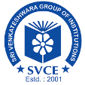

Sri Venkateshwara College of Engineering

**(Accredited by NBA)**

**Department of Civil Engineering**

Vidyanagar, BIA Road

Bengaluru, Karnataka 562 157

[www.svcengg.com](http://www.svcengg.com)

***In Association with***

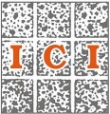******

***Indian Concrete Institute***



***The Institution of Engineers (India)***

**Organizing Committee:**

**Chief Patron**

**Mr. V. Muniyappa Dr. Shashidhar M**

Chairman Chief Executive Director

Sri Venkateshwara Group of Institutions

**Er. Ravishankar M Dr. Radhakrishna**

Chairman Secretary

Indian Concrete Institute, Bengaluru

**Patron**

**Dr. Suresha**

Principal, SVCE, Bengaluru.

**Convenor**

**Dr. H N Rajakumara**

Professor and Head of the Department,

Department of Civil Engineering, SVCE,

Bengaluru

+91 9632548043, hodcivil@svcengg.com

**Coordinators**

**Dr. Latha M S**

Associate Professor, SVCE, +91 9986054960

**Mrs. Anusha M**

Assistant Professor, SVCE, +91 9108900186

**Mr. Manoj V**

Assistant Professor, SVCE, +91 8892531625

**Mr. Boya Nagaraju**

Assistant Professor, SVCE, +91 7892176748

### OBJECTIVE OF THE WORKSHOP:

The concept of precast construction includes those buildings where the majority of structural components are standardized and produced in plants in a location away from the building, and then transported to the site for assembly. These components are manufactured by industrial methods based on mass production in order to build a large number of buildings in a short time at low cost. The main features of this construction process consist — The division and specialization of the human workforce, the use of tools, machinery, and other equipment, usually automated, in the production of standard, interchangeable parts and products This type of construction requires a restructuring of the entire conventional construction process to enable interaction between the design phase and production planning in order to improve and speed up the construction. One of the key premises for achieving that objective is to design buildings with a regular configuration in plan and elevation. This workshop enlighten the issues and challenges in the field of precast construction.

On 24th Oct 2017 (Tuesday), Workshop was inaugurated by the Chief Guest, Mr. M N Ramesh, Director, Talrak Construction Chemicals Pvt. Ltd., Bangalore, Principal Dr. Suresha, Sri Venkateshwara College of Engineering and Dr. H N Rajakumara, head of Department, Civil Engineering, Sri Venkateshwara College of Engineering, Faculties and Students from 9:30 AM to 10:30 AM.

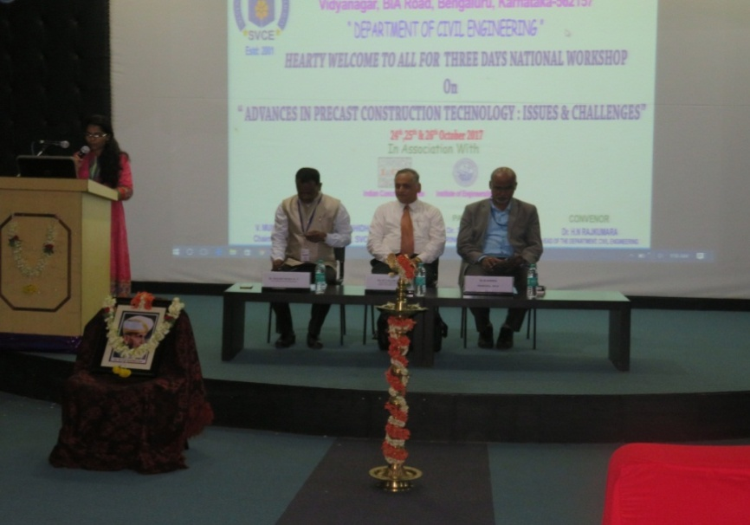

Session 1 was started by Chief Guest, Mr. M N Ramesh, on Precast Construction in India. Using power point presentation, explained about the construction using precast elements like hollow slabs, precast beam-column, etc. from 10:45 AM to 11: 45 AM. Many queries were raised by students that were very well responded by the speaker.

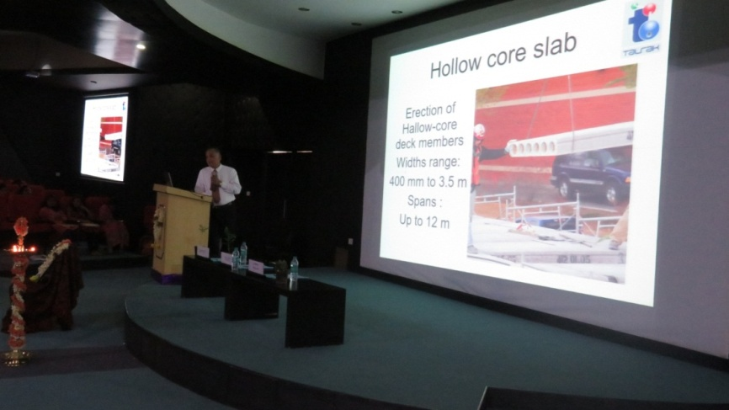

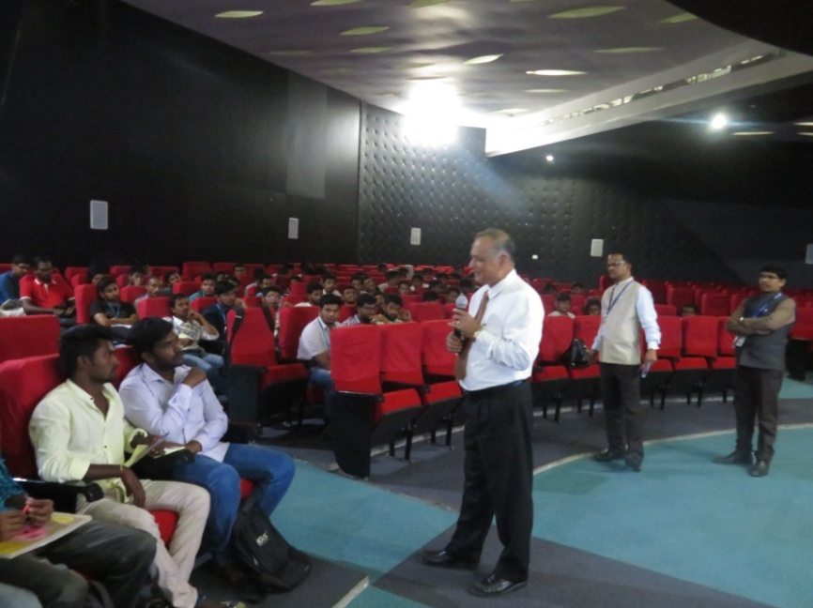

 Speaker Mr. Biswas Kumar K, Founder Partner, **Mooreliving India Building Solutions LLP**  
[Email: biswas@moorelivingindia.com](mailto:Email:%20biswas@moorelivingindia.com), [www.moorelivingindia.com](http://www.moorelivingindia.com), took up session II between 12:00 to 1:00 PM. **G**ave presentation on why concrete is used, pre-cast concrete, its advantages. MIBS panel Tec**hnology, MODUCAST system of housing, s**tages of assembling at plant, moducast® process, stages of assembling at site, examples of assembled buildings in Bangalore, installation process. Environmental resistance, cost comparison.

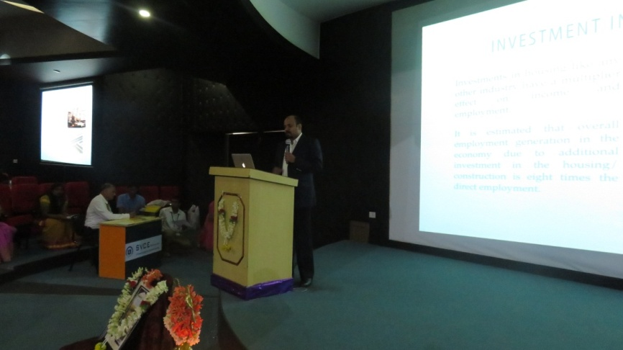

Session 3 started at 2:00pm by speaker Mr. Chandrashekar L H, Engineering Manager, TRIMBLE Solutions India Pvt. Ltd., Bangalore. He introduced the participants about the software TELKA STRUCTEURES BIM, and its versatility in analyzing and designing.

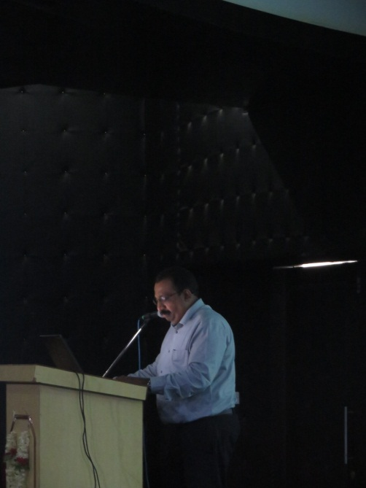

On the second day of workshop, 25th Oct. 2017(10:00 – 11:00 AM), Session 4 started with our Professor Somasekhar D P, Assistant Professor, Department of Civil Engineering, SVCE, presented on Design of precast elements, using worksheets. Session was interactive and interesting.

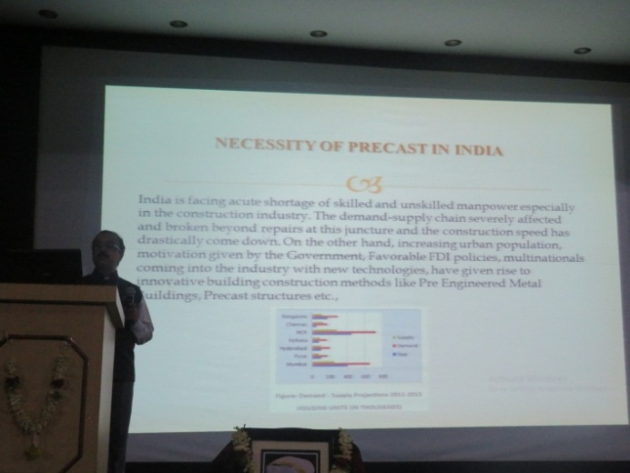

Session 5 started at 2:00pm by speakers Vijendra Kumar Ahirwar, project manager and Pradeepa, senior structural engineering -precast engineering group, TRC**Engineering (I) Pvt.  ltd.,** a TRC worldwide engineering company, Kormangala Industrial layout, Bangalore – 560 095. TRC has worked on many high rise structures in US, Malaysia and in India. We use ETABS and RAM Steel to model concrete and steel structure respectively. Mat and Raft foundations are analyzed and designed using SAFE software. Speakers presented on “Design and Construction of Precast Structures in India and worldwide”. Gave few examples of the projects the Group has been involved with are: Software Development Centers and Multi Level Vehicle Parking Structures for Infosys at various campuses, etc.

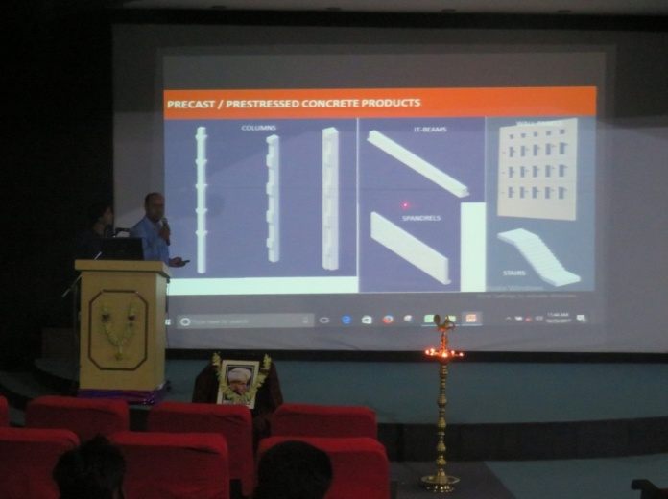

Site visit was taken by the workshop to the precast element construction at Uttanaalli, SVR Pvt. Construction. College buses were facilitated to transport the workshop candidates to the site between 2:00 PM and 3:00 PM. Candidates enriched the practical knowledge of construction. Site consisted of compound wall panel element, stiffners elements. Many panel construction was demonstrated.

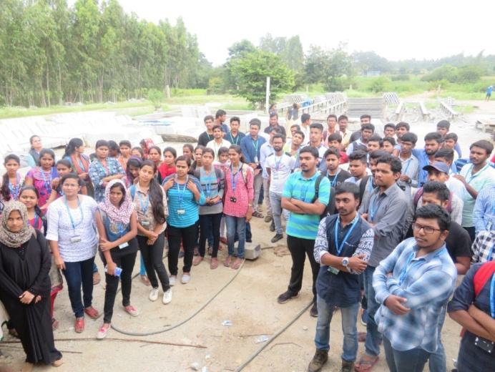

On third day (26t Oct 2017), workshop started wit session 6, speaker was Mr. Byre Gowda, SVR Precast groups, on “Precast Products” Production and Latest Developments between 10:00 AM to 11:00 AM.

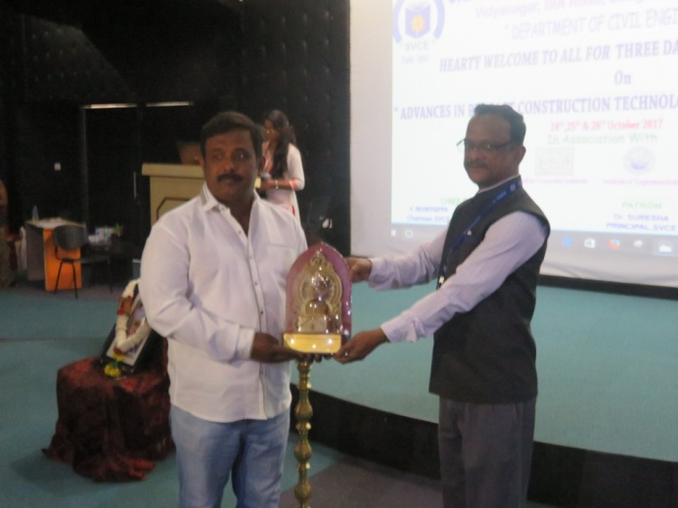

Speaker of session 7 was Mr. PADDY MENON-Director & Mr. Manoj Patterson, “REBEL DISRUPTIVE BUILDING TECHNOLOGIES”, presented on “Precast concrete/Pre-fabricated structures” Construction and Latest Developments. Session was very interactive and speaker distributed REBEL T shirts to participants for answering is questions on construction.

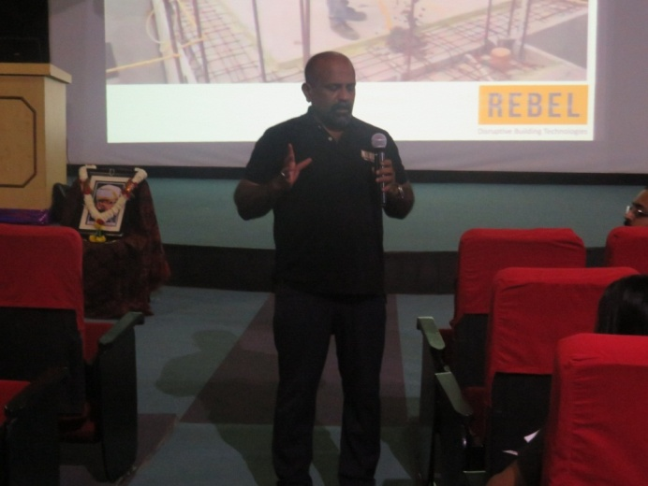

Valedictory program was scheduled at 2:00 PM at SVCE Auditorium, OD and Principal congratulated for the success of workshop. Certificates were distributed and thanked Indian Concrete Institute and The Institution of Engineers, India, for all the support.

