Report on: One Day National Seminar

On “Green Building and Sustainable Habitats”

Organized by: JSS Academy of Technical Education

Department of Civil Engineering

On Saturday, 14th October 2017, Bengaluru – 560 060

Seeking blessings of **His Holiness Jagadguru Sri Shivarathri Deshikendra Maha Swamiji** and also remembering **Dr. APJ Abdul Kalam** on his 86th Birth Anniversary; Inter-disciplinary Research Center & Civil Engineering Research Center of JSSATE Bangalore in Association with ICI   made   an    attempt   to take **the Green Tech to the** people by organizing a National Seminar on "**Green Buildings and Sustainable Habitats"** at JSSATE Bangalore.

 This National seminar was inaugurated by Er. Puneet Kumar Vats, Additional Director General , CPWD, GOI as the Chief Guest and Sri HN Vijaya Raghav Reddy, President, Builders Association of India as Guest of Honor. The Inaugural program was also graced with the presence of Er. Ravishankar, ICI (BC).

The Seminar had four Technical Sessions namely Green Building Concept, Green Building Materials, Best Practices and Global Practices & Certification by US-GBCI were held. There were around 100 participants attended the seminar. Its valedictory   program was chaired by Dr. Radhakrishna, Secretary, ICI (BC).

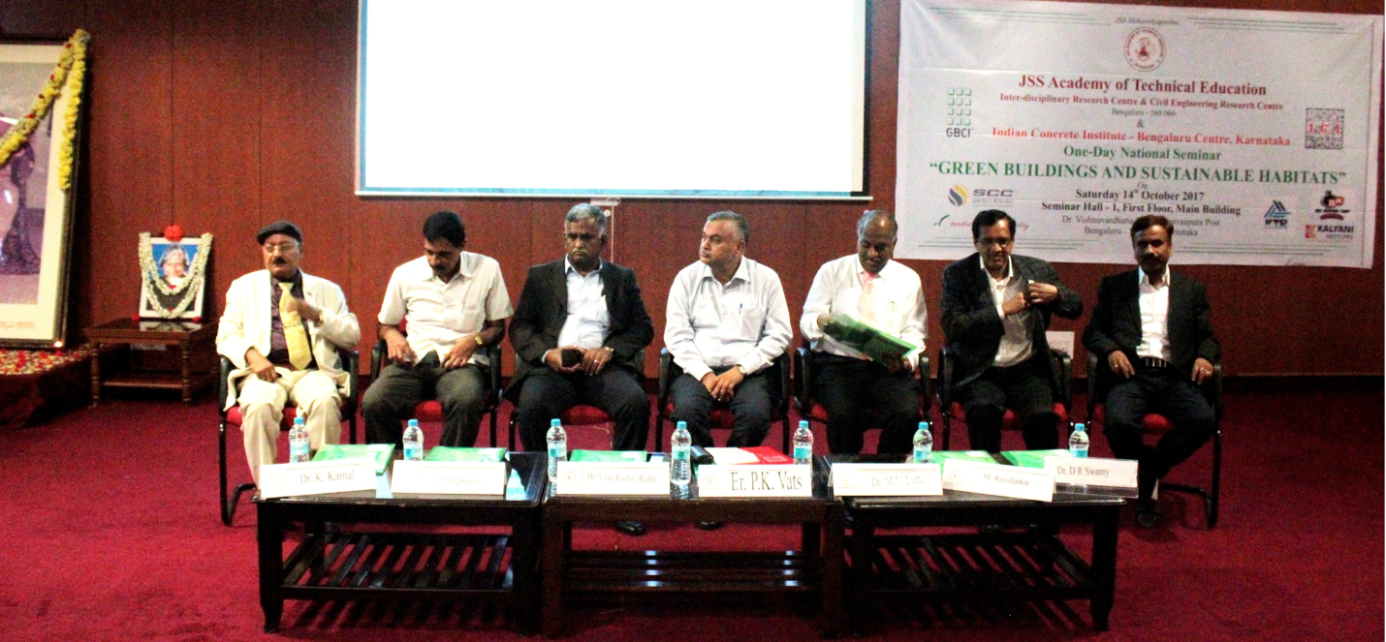

Inaugural Function of “Green Buildings and Sustainable Habitats”

National seminar held on 14.10.2017 at JSSATE Bangalore.

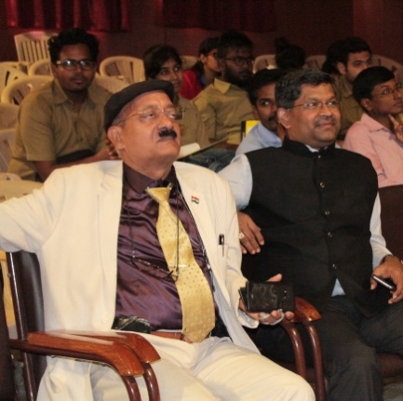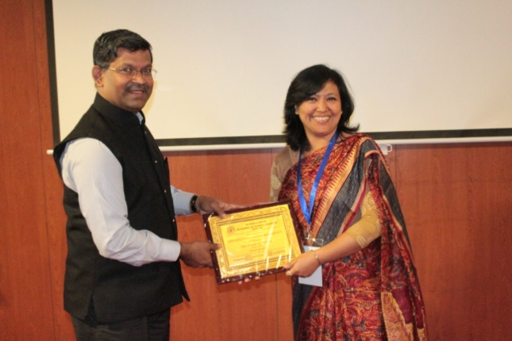

Valedictory chaired by

Dr. Radhakrishna, Secretary, ICI (BC)

