**One Day workshop on**

**“PERSPECTIVE INSIGHT OF TRANSPORTATION SYSTEM**

**FOR SMART CITIES”**

The One Day Workshop started with the Dignitaries being welcomed and escorted with warm greetings on to the dais. The dignitaries were further welcomed with floral bouquets along with a welcome speech by Prof. N Chiranthana. All our esteemed guests then inaugurated the function by lighting the lamp which filled the air with positivity. The guests were then felicitated by our beloved Chairman Shri. D K Mohan Sir and our ever encouraging Principal Dr. Suresh L along with a momento.

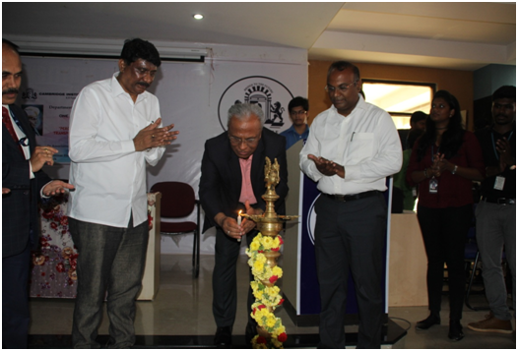

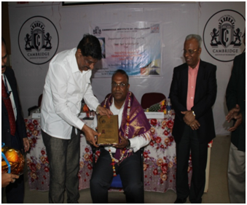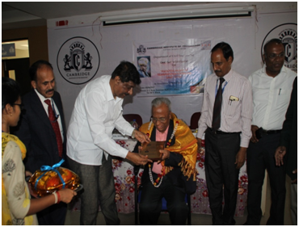

The Chief Guest for the event Prof. M N Sreehari, Expert Member, Smart Cities GoI, CEO, Consortia of Infrastructure Engineers and Advisor to Govt. of Karnataka for traffic, transport & infrastructure gave an elaborative lecture on the topic “Sustainable Smart Cities for India – Need of the hour”.  He emphasized on having Smart Cities who have Smart people. He also put forward the need for Sustainable development of infrastructure so that our future is secure and smart.

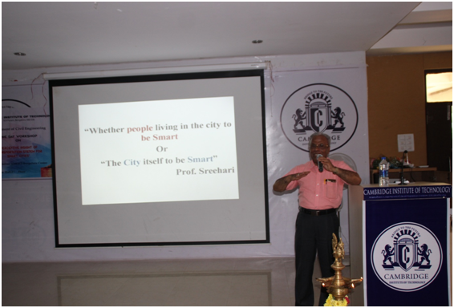

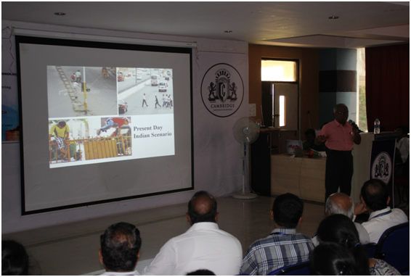

Our esteemed Guest of Honor Er. B G Raghavendra Prasad, Executive Engineer (Road Infrastructure) BBMP, Bangalore enthralled the students and faculties alike on the topic of “White Topping” which is an innovation in pavement repair and rehabilitation. He gave a complete overview of the technology that goes into making of the White Topping and its pre-requisites.

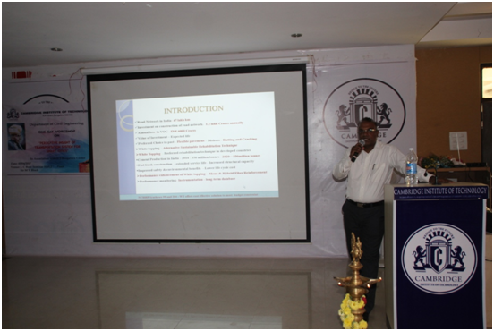

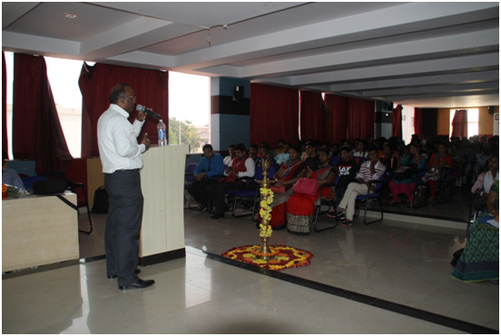

An industry expert Er. Veera Biradar, ‎Managing Director at Transheight Consultants Pvt. Ltd., made the students understand the actual need for being smart with all our gadgets and understand the technology behind them. She also suggested us that all our generations should be able to be gadget friendly and everyone either old or young should embrace the technology with open minds. In a gist, she gave an overview about Urban Transportation System.

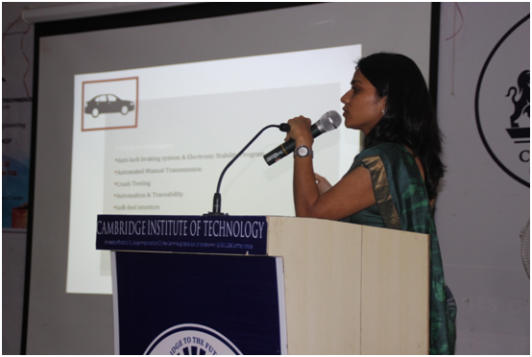

Another industry expert Er. Ananda G, Director, Apt Consulting Engineering Services gave an interesting presentation on various facilities under the Smart Cities concept for “Effective Transportation Management System”. He gave an insight into the existing projects based on the Smart Cities such as BST and others.

